# ***Challenge Name :- Hy(dra's Hurdles***

**Description:** Prepare to embark on 'Hydra's Hurdles,' a CTF challenge where your cybersecurity prowess will be put to the test amidst a maze of misleading clues. Navigate through layers of intricate puzzles, where distinguishing truth from deception is your greatest challenge. Can you unravel Hydra's web of obstacles and emerge triumphant?

**Level:** Hard

**Solution:**

**Step-1:** You will see a web page with a search box **.** 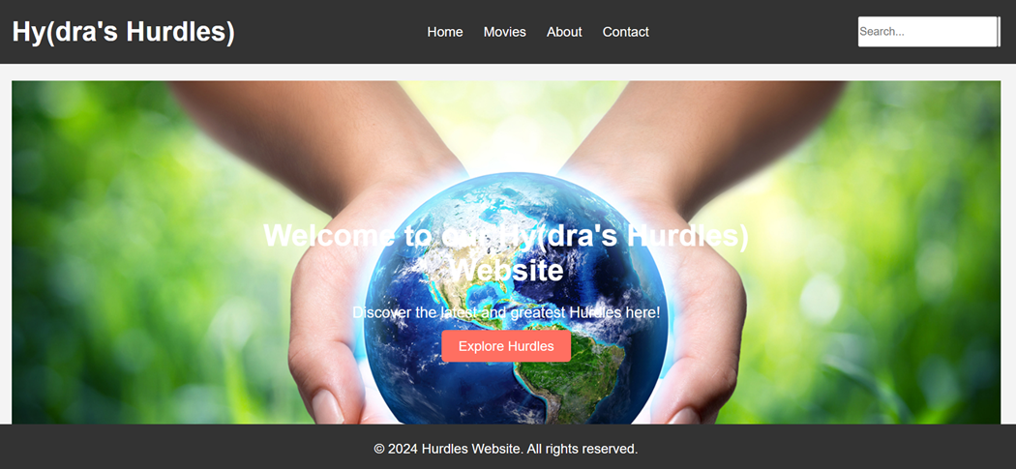

**Step-2:** You have search any thing you will navigate to search.php . After a lot of effort you got nothing , back to index page and review the code you will see some parameter only one is responsible for flag.

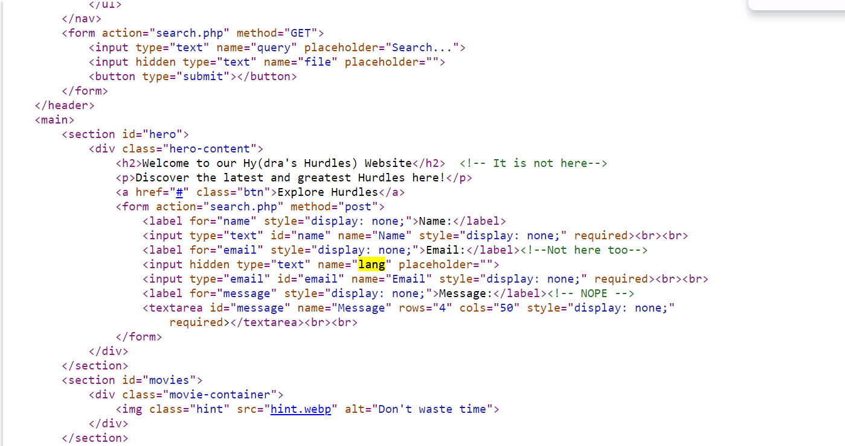

Step-3: When you try lang=/etc/shadow you will get nothing then again review the code you will get comment dir1 in JS file.

Step-4: Simple use /etc/dir1/shadow and get the flag. Qw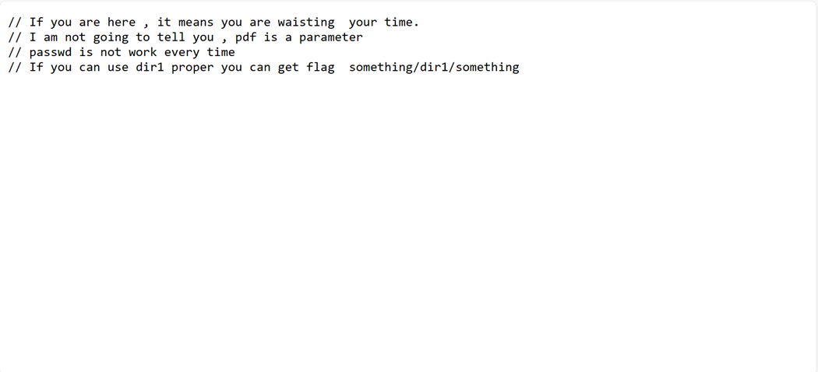

Flag: flag{g4e1_w0rk} 

This page is intentionally left blank